Sri Lanka Institute of Information

Technology



Lab Submission

Lab sheet 06

**IT24101921**

**C.R.Jayawickrama**

**Probability and Statistics| IT2120**

B.Sc. (Hons) in Information Technology

Exercise

1.

i)

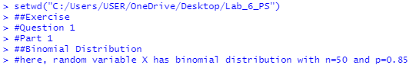

ii)

2.

i)



ii)



iii)

